WEEKLY LESSON PLAN

WEEK THREE
BASIC SIX
SUBJECT: MATHEMATICS
Week Ending: |  |  |  |  | Class size:
Day : |  |  |  | Date :
Period : |  |  |  | Lesson :
Strand : GEOMETRY AND MEASUREMENT |  |  | Sub-strand : Measurement
Indicator (code) |  | B5.3.2.1.1 B5.3.2.1.2 B5.3.2.1.3
Content standard (code) |  | B5.3.2.1. B5.3.2.1. B5.3.2.1.
Performance Indicator |  | - Learners can estimate perimeter using referents for centimetre and metre, and calculate the actual perimeter and compare  - Learners can calculate perimeter of given shapes in centimetres and metres.  - Learners can calculate surface area of given shapes in centimetres and metres.
Core Competencies: Creativity and Innovation Communication and Collaboration Personal Development and Leadership Critical Thinking and Problem Solving.

Keywords
T. L .R. (s) |  | Counters
Ref: | Mathematics curriculum Page
DAY | Phase 1:  Starter  (preparing the brain | Phase 2: Main  (new learning including assessment) |  |  |  | Phase 3:  Plenary / Reflections

 | for learning)
Monday | Sing songs like:  I’m counting one, what is one 1 - One is one alone, alone it shall be. 2 - Two pair, two pair come pair let us pair | Using pupils’ referents for centimetre (hand span and thumb width) or metre (two strides or pace steps) estimate and calculate perimeter of any object in the classroom (e.g. exercise book, floor tiles, math set, teacher’s table, classroom floor, etc.) then measure with a ruler of tape and calculate the actual perimeter and compare the answers.  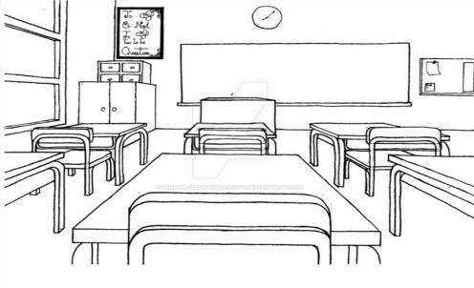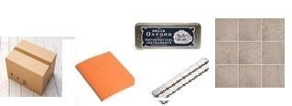  Assessment: have learners to practice with more examples | Review the lesson with  Learners
Tuesday | Sing songs like:  I’m counting one, what is one 1 - One is one alone, alone it shall be. | Give learners 2D shapes with given dimensions to find the perimeter by adding the distance around the shapes  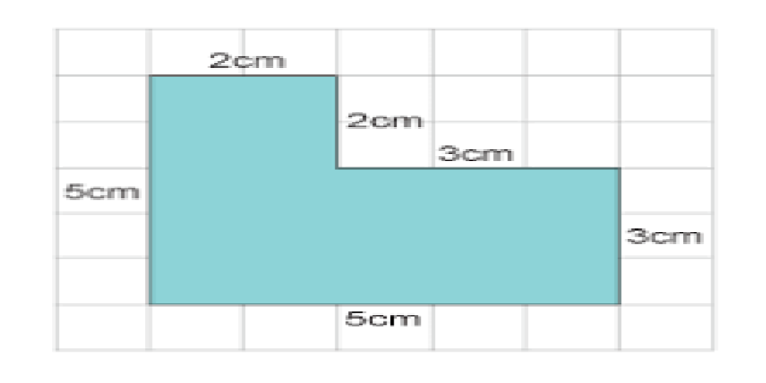  Assessment: have learners to practice with more examples | Review the lesson with  Learners
Wednesday | Sing songs like:  I’m counting | Give learners 2D shapes with given dimensions to find the perimeter by adding the distance around the shapes | Review the lesson with  Learners

 | one, what is one 1 - One is one alone, alone it shall be.  2 | 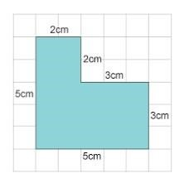  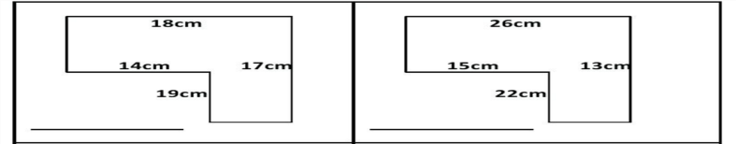  Assessment: have learners to practice with more examples
Thursday | Sing songs like:  I’m counting one, what is one 1 - One is one alone, alone it shall be. | 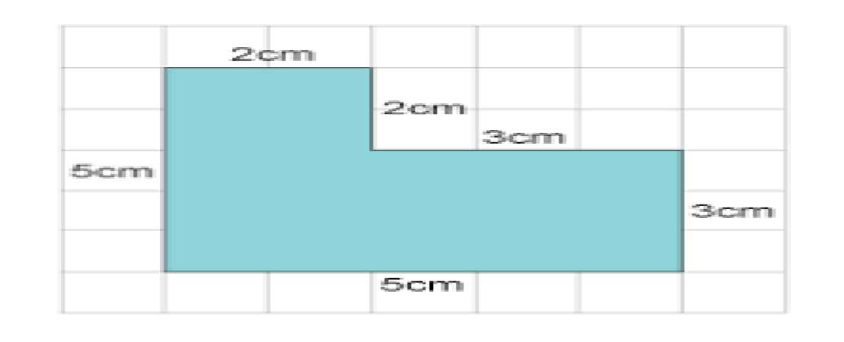  Give learners compound 2D shapes that can be spilt to many rectangles with given dimensions to find the surface area by adding areas of the various rectangles  Assessment: have learners to practice with more examples | Review the lesson with  Learners
Friday | Sing songs like:  I’m counting one, what is one 1 - One is one alone, alone it shall be. 2 - Two pair, two pair come pair let us pair | Give learners compound 2D shapes that can be spilt to many rectangles with given dimensions to find the surface area by adding areas of the various rectangles  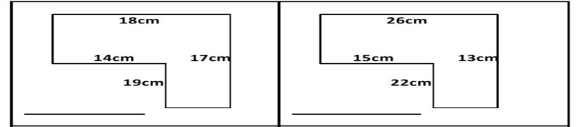  Assessment: have learners to practice with more examples | Review the lesson with  Learners

