BASIC 7
WEEKLY LESSON PLAN – WEEK 2
Strand: | Health and safety |  |  | Sub-Strand: |  |  |  |  | Personal hygiene and food hygiene
Content Standard: | B7.1.1.1 Demonstrate knowledge of basic concept of staying healthy
Indicator (s) | B7.1.1.1.1: Explain the need to stay healthy |  |  |  |  |  | Performance Indicator: Learners can explain the need to stay healthy.
Week Ending | 18-09-2026
Class | B.S.7 |  | Class Size: |  |  |  |  | Duration:
Subject | Career Technology
Reference | Career Technology Curriculum, Teachers Resource Pack, Learners Resource Pack
Teaching / Learning Resources | Tooth brush and Paste, Sanitizer, Soap, water, Pictures. |  |  |  |  | Core Competencies: |  |  |  | - Communication and Collaboration  - Critical Thinking and Problem Solving  - Creativity and Innovation.
DAY/DATE | PHASE 1 : STARTER | PHASE 2: MAIN |  |  |  |  |  |  |  |  |  | PHASE 3: REFLECTION
MONDAY | Review Learners knowledge on Personal hygiene through questions and answers. | - Assist Learners to explain the meaning of Food hygiene based on the knowledge they have on Personal hygiene.  - Learners in small groups to discuss on the practices of Food hygiene and report to the class.  - Discuss 3 proper ways of storing and preserving food.  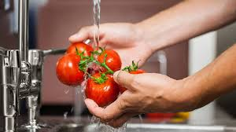  Food hygiene is defined as 'the measures and conditions necessary to control hazards and to ensure fitness for human consumption of a foodstuff taking into account its intended use.  Proper Storage and Preservation ways;  - Drying/Dehydrating  Canning – Water Bath Canning, Steam Canning and Pressure Canning  Freezing  Freeze Drying  Fermentation  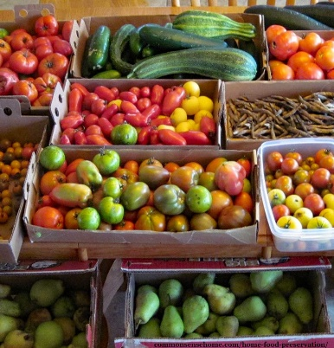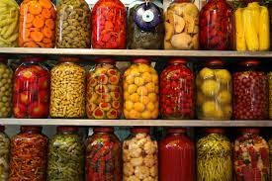  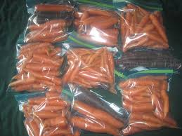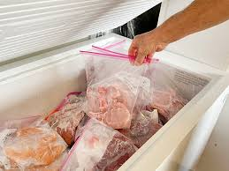 |  |  |  |  |  |  |  |  |  | Through questions and answers, conclude the lesson.  Assignment;  - What is Food Hygiene?  - Differentiate between Personal Hygiene and Food Hygiene.  - State 3 best ways of storing and preserving food.
THURSDAY | Show a video of ways of maintaining Personal hygiene to the Learners. | - Learners brainstorm to explain ways of maintaining Personal hygiene.  - Discuss with Learners ways of caring for our finger nails, hair, nose, ear, mouth and teeth.  - Demonstrate how to brush teeth whilst Learners observe.  - Learners practice how to brush teeth.  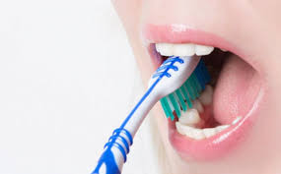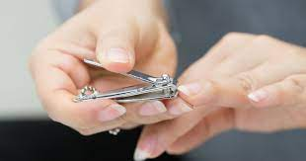  Taking care of Fingernails;  - Keep nails clean and dry.  - Cut nails straight across.  - Keep nails shaped and free of snags by filing with an emery board.  - Do not bite fingernails or remove the cuticle.  - Do not use your nails as a tool, such as opening pop cans.  - Trim toenails regularly  What is the correct way to brush your teeth?  Hold the bristles gently against the outside of your top teeth, near the gum line, at about a 45-degree angle upward. Sweep the brush gently back and forth over teeth and gums in soft strokes — or, if you prefer, use an elliptical (circular) motion to clean the teeth. |  |  |  |  |  |  |  |  |  | Ask Learners to talk about the need to maintain Personal hygiene.  Practical;  - Learner’s practice proper way of brushing teeth.  - Cutting of fingernails.

Name of Teacher: School: District:

