BASIC 7
WEEKLY LESSON PLAN – WEEK 5
Strand: | Design |  |  | Sub-Strand: |  |  |  |  | Drawing, shading, colouring and modelling for design
Content Standard: | B7/JHS1 1.2.1. Demonstrate understanding and use of (outline drawing, shading, colouring) and modelling media and techniques for creative expression of design ideas.
Indicator (s) | B7/JHS1 1.2.1.1  Explore available manual and digital tools, materials and techniques for outline drawing, shading and colouring to create designs from lines and simple shapes |  |  |  |  |  | Performance Indicator: Learners can make outline drawings, shade and colour.
Week Ending | 09-10-2026
Class | B.S.7 |  | Class Size: |  |  |  |  | Duration:
Subject | Creative Art and Design
Reference | Creative Art Curriculum, Teachers Resource Pack, Learners Resource Pack, Textbook.
Teaching / Learning Resources | T-square, set square, protractor, paper, cardboard, pencil |  |  |  |  | Core Competencies: |  |  |  | - Communication and Collaboration  - Creativity and Innovation.
DAY/DATE | PHASE 1 : STARTER | PHASE 2: MAIN |  |  |  |  |  |  |  |  |  | PHASE 3: REFLECTION
MONDAY | Discuss the meaning of Outline drawing with the Learners. | - Learners brainstorm to identify manual tools and materials for outline drawing.  - Demonstrate the techniques for outline drawing, shading and colouring of Outline drawing.  - Assist Learners to draw, shade and colour outline drawings.  Outline drawing;  Outline Design bridges the gap between Concept Design and Detailed Design and may require additional information to ensure that all aspects of the design are fully considered. Facing: The outline design has developed the concept proposals to demonstrate how the scheme works and what it will look like when built.  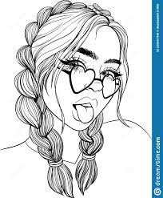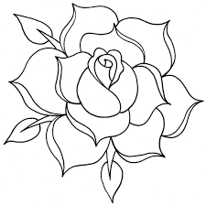  Techniques for outline drawing;  - Small dashes.  - Hatching (long, parallel lines on an angle)  - Cross-hatching (parallel lines at right angles)  - Stippling (dots)  - Scribbles.  - Small crosses.  - Small circles. |  |  |  |  |  |  |  |  |  | Reflect on the techniques for outline drawing, shading and colouring.  Exercise;  - What is an Outline drawing?  - Write 3 tools and materials for outline drawing.  - Explain 3 techniques for outline drawing.
THURSDAY | Learners brainstorm to differentiate between freehand and outline drawing. | - Demonstrate using available manual tools, materials and techniques for freehand and outline drawings, shading and colouring.  - Learners in groups to discuss how to create  designs from lines, simple shapes and form.  - Each group to report on their design work.  Freehand Drawing;  A freehand sketch consists of many straight-line segments, created either as individual line entities or as a polyline.  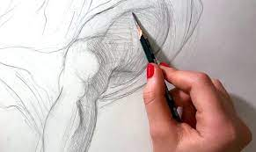  Designs from Lines, simple shapes and Forms;  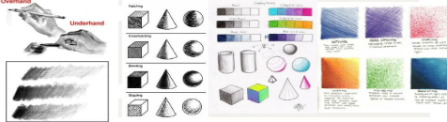  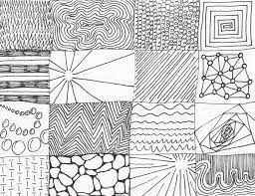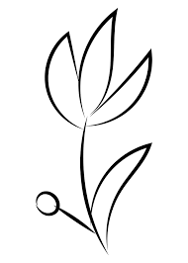 |  |  |  |  |  |  |  |  |  | Inspect, appraise and comment on each groups design work.
Name of Teacher: School: District:

