BASIC 8
WEEKLY LESSON PLAN – WEEK 4
Strand: | Religious Practice |  |  | Sub-Strand: |  |  |  |  | Rites of Passage
Content Standard: | B8.2.1.1 Explain rites of passage and identify the moral importance in them
Indicator (s) | B8.2.1.1.2 Explain physical and emotional changes that characterize puberty. |  |  |  |  |  | Performance Indicator: Learners can identify physical and emotional changes in Adolescents.
Week Ending | 02-10-2026
Class | B.S.8 |  | Class Size: |  |  |  |  | Duration:
Subject | Religious and Moral Education
Reference | RME Curriculum, Teachers Resource Pack, Learners Resource Pack, Textbook.
Teaching / Learning Resources | Poster, Pictures, Video, Power Point Presentation. |  |  |  |  | Core Competencies: |  |  |  | - Literacy  - Global Citizenship  - Cultural Identity
DAY/DATE | PHASE 1 : STARTER | PHASE 2: MAIN |  |  |  |  |  |  |  |  |  | PHASE 3: REFLECTION
MONDAY | Learners brainstorm to explain the meaning of Puberty. | - Assist Learners to differentiate between Puberty and Puberty Rite.  - Discuss with Learners 5 examples of Puberty Rites in Ghana and where they are performed.  - Assist Learners to role play on how a Puberty is performed.  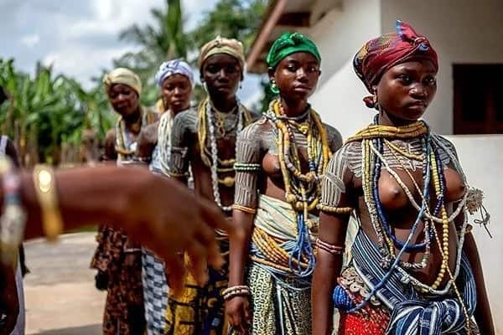  After the child naming ceremony, puberty rites are the next set of rituals of social status transformation which children undergo in Ghanaian culture. The most well-preserved puberty rites are the Dipo (pictured) of the Krobo ethnic group and the Bragoro of the Ashanti's. These ceremonies mark the entry of young women into adulthood. In Ghana only a small section of ethnic groups usually found in the northern parts of the country have initiation rites for men and where they occur they are done in secret and not given as much prominence as that for young women.  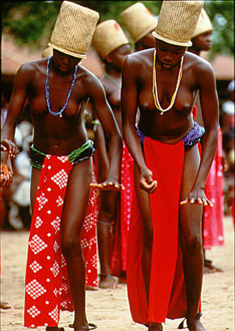  Examples of Puberty Rites in Ghana;  - Dipo  - Bragoro  - Nugbeto  - Otofo |  |  |  |  |  |  |  |  |  | Through questions and answer, conclude the lesson.  Exercise;  - Write 5 examples of Puberty Rites in Ghana.
THURSDAY | Review Learners knowledge on the previous lesson. | - Using a Power Point Presentation, explain the importance of Puberty Rite.  - Assist Learners to identify 5 advantages and disadvantages of some Ghanaian Puberty Rites.  - Discuss with Learners examples of Puberty Rites that needs to be abolished.  - Learners brainstorm to explain Female Genital Mutilation.  - Learners in small groups to discuss effects of Female Genital Mutilation.  Advantages of Puberty;  - Puberty results in very rapid somatic growth  - brain development  - sexual maturation  - attainment of reproductive capacity  Female Genital Mutilation; Female genital mutilation (FGM) is a procedure where the female genitals are deliberately cut, injured or changed, but there's no medical reason for this to be done.  Effects of female genital Mutilation  There are no health benefits to FGM and it can cause serious harm, including:  - constant pain  - pain and difficulty having sex  - repeated infections, which can lead to infertility  - bleeding, cysts and abscesses  - problems peeing or holding pee in (incontinence)  - depression, flashbacks and self-harm  - problems during labour and childbirth, which can be life threatening for mother and baby |  |  |  |  |  |  |  |  |  | Each group is to report on their discussions on the effects of Female Genital Mutilation.  Exercise;  - Write 5 advantages of Puberty.  - Explain Female Genital Mutilation.

Name of Teacher: School: District:

