BASIC 8
WEEKLY LESSON PLAN – WEEK 5
Strand: | Number |  |  | Sub-Strand: |  |  |  |  | Number and Numeration Systems
Content Standard: | B8.1.1.2 Apply the concepts and vocabulary of sets on sets of factors of numbers to identify perfect squares, determine their square root and solve real life problems involving union and intersection of two sets
Indicator (s) | B8.1.1.2.1.Use the concept of sets to identify perfect squares and determine the square roots. Use the knowledge on sets and sets of factors of numbers to solve problems  B8.1.1.2.2. Use the knowledge on sets and sets of factors of numbers to solve real life problems involving union and intersection |  |  |  |  |  | Performance Indicator: Learners can solve word problems involving union and intersection.
Week Ending | 09-10-2026
Class | B.S.8 |  | Class Size: |  |  |  |  | Duration:
Subject | Mathematics
Reference | Mathematics Curriculum, teachers Resource Pack, Learners Resource Pack, Textbook.
Teaching / Learning Resources | Poster, Pictures, Word Chart. |  |  |  |  | Core Competencies: |  |  |  | - Demonstrate a thorough understanding of a generalized concept and facts specific to task or situation.  - Ability to select alternative(s) that adequately meet selected criteria
DAY/DATE | PHASE 1 : STARTER | PHASE 2: MAIN |  |  |  |  |  |  |  |  |  | PHASE 3: REFLECTION
MONDAY | Review Learners knowledge on sets of numbers and factors of numbers. | - Assist Learners to list sets of multiples of numbers and identify a set of perfect numbers among them.  - Learners brainstorm to identify perfect square numbers from the list of set of multiples of numbers.  - Learners in small groups to solve more examples of identifying perfect numbers and perfect squares from a set of multiples.  What are Perfect Numbers?  A perfect number is a positive integer that is equal to the sum of its factors except for the number itself. In other words, perfect numbers are the positive integers that are the sum of its divisors. The smallest perfect number is 6, which is the sum of its factors: 1, 2, and 3. It is to be noted that this sum does not include the number itself which is also a factor of itself.  Important Notes  - Perfect numbers are the positive integers which are the sum of their proper divisors.  - The smallest perfect number is 6.  - All the perfect numbers are even numbers. It is still unknown whether odd perfect numbers exist or not.  - All the perfect numbers end in 6 and 8 alternatively.  The first 12 perfect squares are: {1, 4, 9, 25, 36, 49, 64, 81, 100, 121, 144...} Perfect squares are used often in math. Try to memorize these familiar numbers so that you can recognize them as they are used in many math problems. |  |  |  |  |  |  |  |  |  | Through questions and answers, conclude the lesson.  Exercise;  - What are Perfect numbers?  - Define Perfect squares.  - Select the Perfect numbers from the following numbers;  - 5, 10, 15, 20, 25, 30, 35, 40, 45, 50, 55  - 2, 4, 6, 9, 12, 16, 18  - 4, 8, 12, 16, 20, 2
  Perfect Number | Sum of Divisors
  6 | 1 + 2 + 3
  28 | 1 + 2 + 4 + 7 + 14
  496 | 1 + 2 + 4 + 8 + 16 + 31 + 62 + 124 + 248
  8128 | 1 + 2 + 4 + 8 + 16 + 32 + 64 + 127 + 254 + 508 + 1016 + 2032 + 4064
WEDNESDAY | Discuss the meaning of square roots with the Learners. | - Demonstrate how to find the square root of numbers.  - Assist Learners to calculate for the square root of numbers.  - Learners individually brainstorm to calculate for the square roots of perfect numbers.  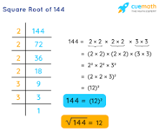  Finding the square of numbers;  Squaring a Single Digit Number  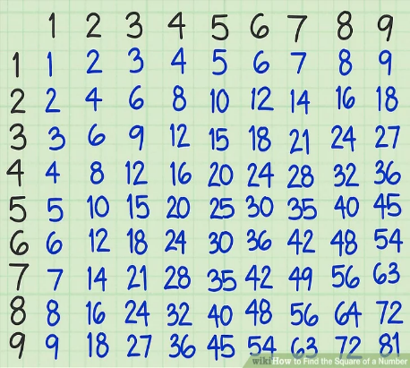  Squaring Larger Numbers.  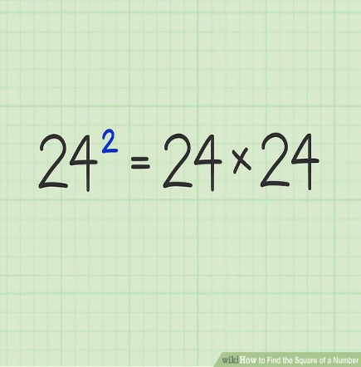  Squaring Fractions  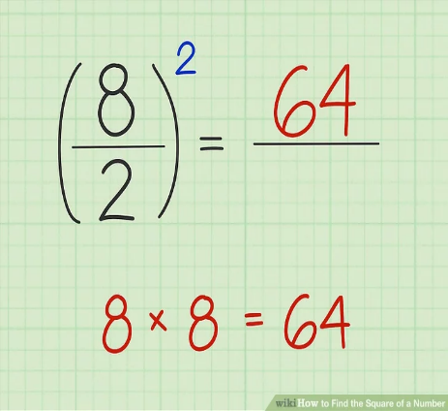 |  |  |  |  |  |  |  |  |  | Reflect on how to calculate for the square root of numbers.  Exercise;  - Write the square of the following digits;  - 3  - 5  - 2  - 9  - 1  - Find the square root of the following numbers;  - 49  - 25  - 9  - 16  - 64
FRIDAY | Show Learners a Poster displaying the Factors of numbers. | - Learners brainstorm to explain the meaning of Factors of numbers.  - Assist Learners to write the set of Factors of numbers.  - Discuss and solve with Learners story problems involving unions and intersection of sets.  - Learners in small groups to represent word or story problem involving union and intersection on a Venn diagram  Factors of Numbers;  15 { 1, 3, 5 and 15}  12 { 1, 2, 3, 4, 6 and 12}  4{ 1, 2 and 4.}  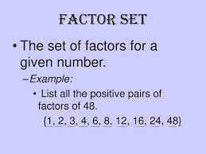  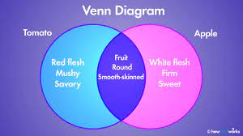 |  |  |  |  |  |  |  |  |  | Through questions and answers, conclude the lesson.  Exercise;  Write the factors of the following numbers;  - 36  - 24  - 18  - 12  - 9  Assignment;  There are 80 farmers in a certain village who grow maize and rice or both. Out of the  80 farmers, 50 grow maize and 60 grow rice.  (a) represent the information on a Venn diagrams  (b) if X of them grow both crops, write an equation in X and solve

Name of Teacher: School: District:

