BASIC 9
WEEKLY LESSON PLAN – WEEK 1
Strand: | - Oral language (listening and speaking)  - Reading  - Grammar Usage  - Writing |  |  | Sub-Strand: |  |  |  |  | - Conversation/everyday discourse  - Comprehension  - Grammar  - Production and Distribution of Writing
Content Standard: | B9.1.1.1: Demonstrate the use of appropriate language orally in specific situations ( Oral language)  B9.2.1.1: Demonstrate increasing confidence and enjoyment in independent reading.(Reading)  B9.3.1.1:Apply the knowledge of phrases and clauses and their functions in Communication.(Grammar Usage)  B9.4.1.1: Develop, organize and express ideas coherently and cohesively in writing(Writing)
Indicator (s) | B9.1.1.1.1. Use appropriate register in everyday communication (informal and formal) with diverse partners on grade-level topics/texts/issue(Oral language)  B9.2.1.1.1. Read a variety of grade level texts and demonstrate understanding(Reading)  B9.3.1.1.1. Use noun phrases accurately in context (Grammar Usage)  B9.4.1.1.1. Compose logically connected paragraphs to show unity, completeness and coherence using appropriate cohesive devices, e.g., connectors, pronouns, repetition of vocabulary or grammatical structures (Writing)
Week Ending | 11-09-2026
Class | B.S.9 |  | Class Size: |  |  |  |  | Duration:
Subject | English Language
Reference | English Language Curriculum, Teachers Resource Pack, Learners Resource Pack, Textbook
Teaching / Learning Resources | Word Chart, Sentence Cards, Poster, Dictionary, Audio Set |  |  |  |  | Core Competencies: |  |  |  | - Evaluate the quality and validity of information  - Explain ideas in a clear order with  relevant details, using correct construction and structure of speech
DAY/DATE | PHASE 1 : STARTER | PHASE 2: MAIN |  |  |  |  | PHASE 3: REFLECTION
MONDAY | Strand: Oral Language – Listening and speaking  Sub-Strand- Conversation/Everyday Discourse  Discuss a Poster bearing examples of formal and informal language sentences with the Learners. | - Learners brainstorm to mention examples of some slang words and jargon accepted locally and internationally.  - Assist Learners to form sentences with formal and informal register.  - Select a grade-level texts from the textbook for the Learners to read on formal and informal language.  The difference between formal and informal language?  Formal and informal language serves different purposes. The tone, the choice of words and the way the words are put together vary between the two styles. Formal language is less personal than informal language. It is used when writing for professional or academic purposes like university assignments. Formal language does not use colloquialisms, contractions or first person pronouns such as ‘I’ or ‘We’.  Informal language is more casual and spontaneous. It is used when communicating with friends or family either in writing or in conversation. It is used when writing personal emails, text messages and in some business correspondence. The tone of informal language is more personal than formal language.  Examples of formal and informal language are shown below:  Contractions  Informal: The improvements canʼt be introduced due to funding restrictions.  Formal: Improvements cannot be introduced due to funding restrictions.  Informal: I donʼt believe that the results are accurate.  Formal: The results are not believed to be accurate.  Informal: The research project wonʼt continue next year.  Formal: The research project will not continue next year.  Phrasal verbs  Informal: The balloon was blown up for the experiment.  Formal: The balloon was inflated for the experiment.  Informal: The patient got over his illness.  Formal: The patient recovered from his illness.  Informal: The results of the study were mixed up.  Formal: The results of the study were confused.  Slang/Colloquialisms  Informal: The mob was very rowdy during the protest against cuts to university funding.  Formal: The crowd was very rowdy during the protest against the cuts to university funding.  Informal: Lecturers still count on students to use correct grammar and punctuation in essays.  Formal: Lecturers expect students to use correct grammar and punctuation in essays.  Informal: It was raining cats and dogs.  Formal: It was raining very heavily. |  |  |  |  | Assist learners to differentiate between formal and informal language.
TUESDAY | Strand: Reading  Sub-Strand- Comprehension.  Assist Learners to identify keywords or  vocabularies in the reading text. | 1. Drill Learners on the meanings of the keywords.  2. Select a model reader to read aloud the reading text  to the class.  3. Learners in pairs to read varieties of age-appropriate  texts for enjoyment and knowledge.  4. Assist Learners to understand the text read.  Reading Comprehension skills;  - Decoding  Decoding is a vital step in the reading process. Kids use this  skill to sound out words they‟ve heard before but haven‟t seen  written out. The ability to do that is the foundation for other  reading skills.  - Fluency  To read fluently, kids need to instantly recognize words,  including words they can‟t sound out. Fluency speeds up the  rate at which they can read and understand text. It‟s also  important when kids encounter irregular words, like of and the,  which can‟t be sounded out.  - Vocabulary  To understand what you‟re reading, you need to understand  most of the words in the text. Having a strong vocabulary is a  key component of reading comprehension. Students can learn  vocabulary through instruction. But they typically learn the  meaning of words through everyday experience and also by  Individual Learners to apply  appropriate comprehension  strategies to answer questions on  the texts.  reading.  - Sentence construction and cohesion  Understanding how sentences are built might seem like  a writing skill. So might connecting ideas within and between  sentences, which is called cohesion. But these skills are  important for reading comprehension as well.  - Reasoning and background knowledge  Most readers relate what they‟ve read to what they know. So  it‟s important for kids to have background or prior knowledge  about the world when they read. They also need to be able to  “read between the lines” and pull out meaning even when it‟s  not literally spelled out. |  |  |  |  | Individual Learners to apply  appropriate comprehension  strategies to answer questions on  the texts.
THURSDAY | Strand: Grammar Usage  Sub-Strand- Grammar  Learners brainstorm to distinguish between  Phrases and clauses. | 1. Assist Learners to identify the various types of  Phrases.  2. Discuss with the Learners on the meaning and  examples of noun phrases.  3. Learners brainstorm to use noun phrases in texts.  4. Learners in small groups to discuss and report to the  class on the functions of noun phrases.  What Is a Noun Phrase? (with Examples)  A noun phrase is a group of two or more words headed by a  noun that includes modifiers. In these examples of noun  phrases, the noun is shaded. All the other words are modifiers.  - the dog  (In this example, "the" is a modifier.)  - a cat  (Here, "a" is a modifier.)  - a group of them  ("A" and "of them" are modifiers.)  - the man with her  ("The" and "with her" are modifiers.)  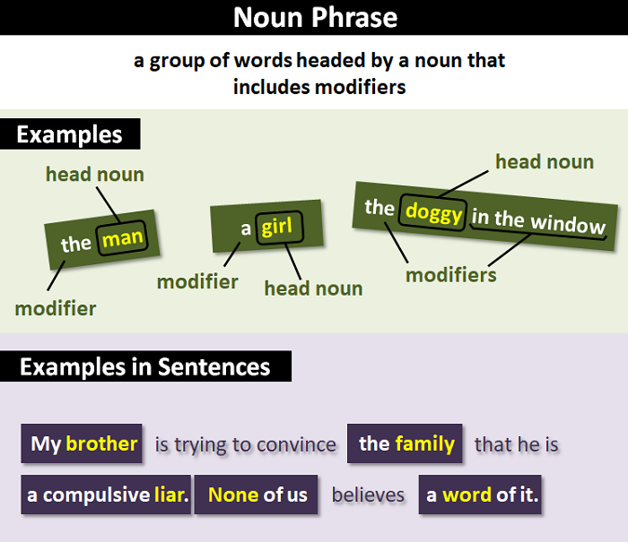 |  |  |  |  | Organize a recap exercise on how to  identify noun phrases in sentences.
FRIDAY | Strand: Writing  Sub-Strand- Production and distribution Writing  Review Learners knowledge on the meaning of conjunctions. | 1. Assist Learners to identify types of conjunctions and  their meanings.  2. Demonstrate on using coordinating conjunctions to  join clauses in compound sentences.  3. Learners brainstorm to write sentences using  coordinating conjunctions to join clauses in compound  Sentences.  4. Assist Learners to practice using subordinating  Conjunctions to join clauses in complex sentences.  Coordinating Conjunction Rules  As there are only seven of these words, there are just a few  rules for using coordinating conjunctions correctly:  1. It‟s a good idea to use the mnemonic “FANBOYS” to  memorize coordinating conjunctions so you‟ll never forget  them. They are:  o F = for  A = and  o N = nor  o B = but  o O = or  o Y = yet  o S = so  2. Coordinating conjunctions always connect phrases, words, and  clauses. For example: This batch of mushroom stew is  savory and delicious.  3. Some instructors warn that starting a sentence with a  coordinating conjunction is incorrect. Mostly, this is because  they are attempting to help prevent you from writing fragments  rather than complete sentences; sometimes though, it‟s just a  personal preference. The fact is, you can begin sentences with  coordinating conjunctions as long as you follow these three  rules for doing so:  o Ensure that the coordinating conjunction is immediately  followed by a main clause  o Don‟t use coordinating conjunctions to begin all of your  sentences. Do so only when it makes your writing more  effective.  o Use a comma before a coordinating conjunction to separate  two independent clauses. They should not be used after  coordinating conjunctions used to open sentences unless an  Interrupter immediately follows.  Examples of Coordinating Conjunctions  In the following examples, the coordinating conjunctions have  been italicized for easy identification.  1. You can eat your cake with a spoon or fork.  2. My dog enjoys being bathed but hates getting his nails  trimmed.  3. Bill refuses to eat peas, nor will he touch carrots.  4. I hate to waste a drop of gas, for it is very expensive these  days.  Recognizing and Using Subordinating Conjunctions  Tip #1: Vary your placement of subordinating conjunctions  Using subordinating conjunctions to write complex  sentences is a GREAT way to elevate your writing to the next  level!  Take advantage of the flexibility of dependent clauses by  rearranging your sentences so you have some sentences  starting with the independent clause and some sentences  starting with the dependent clause.  Tip #2: Subordinating Conjunctions vs Conjunctive Adverbs  Subordinating conjunctions can often be confused with  conjunctive adverbs. Both are used to connect clauses, but  conjunctive adverbs connect two independent clauses, while  subordinating conjunctions connect a dependent clause to  an independent clause.  When checking the connected clauses, look for complete  thoughts. Since a dependent clause cannot stand alone, the  linking word will be a subordinating conjunction.  Name of Teacher: School: District:  - I had a lot of homework today because I wasn‟t paying  attention in class.  In this sentence, “because I wasn‟t paying attention in class” is  a dependent clause using the subordinating conjunction  “because” to add additional details to the independent clause “I  had a lot of homework today”.  - I wasn‟t paying attention in class; consequently, I had  a lot of homework today.  While conveying the same overall idea, this example uses the  conjunctive adverb “consequently” to link the independent  clause “I wasn‟t paying attention in class” to the other  independent clause “I had a lot of homework today.” Both  Clauses are given equal value in the sentence.  Read our post on conjunctive adverbs to learn more about  them.  Tip #3: When looking for subordinating conjunctions, make  sure there is a dependent clause  Some words used as subordinating conjunctions can also be  used for other parts of speech. A good way of checking for  dependent clauses is to find the subject and verb in the part of  the sentence you are linking to the independent clause.  Dependent clauses sound like something is missing, because  they depend on an independent clause to complete the idea.  - I finally could take a break after I ran errands all day.  In this sentence, “after” is a subordinating conjunction. We  can see that “after I ran errands all day” is a clause, because it  has a subject and a verb, but it‟s not a complete thought.  It sounds like we need more information.  - I finally could take a break after a long day.  In this sentence, “after” is a preposition. Since there is not a  subject or verb in “after a long day”, we know it is not a clause,  but rather a prepositional phrase. Read our post on  prepositional phrases to learn more about them!  5. |  |  |  |  | Engage Learners in expanding  sentences using noun phrases,  adjectival phrases and adverbial  phrases.

Name of Teacher: School: District:

