BASIC 9
WEEKLY LESSON PLAN – WEEK 2
Strand: | Design |  |  | Sub-Strand: |  |  |  |  | Creativity, Innovation and the design process
Content Standard: | B9 1.3.1 Demonstrate understanding of creativity and innovation in terms of the design process and its application in developing design solutions to problems in society
Indicator (s) | B9 1.3.1.1 Distinguish between creativity and innovation and their application for developing design solutions to problems in society |  |  |  |  |  | Performance Indicator; Learners can apply creative problem solving and design thinking to solve problems.
Week Ending | 18-09-2026
Class | B.S.9 |  | Class Size: |  |  |  |  | Duration:
Subject | Creative Arts & Design
Reference | Creative Arts & Design Curriculum, Teachers Resource Pack, Learners Resource Pack, Textbook.
Teaching / Learning Resources | Poster showing the difference between Creativity and Innovation, basket, kitchen stool, broom. |  |  |  |  | Core Competencies: |  |  |  | - Communication and Collaboration.  - Critical Thinking and Problem Solving.  - Creativity and Innovation.
DAY/DATE | PHASE 1 : STARTER | PHASE 2: MAIN |  |  |  |  |  |  |  |  |  | PHASE 3: REFLECTION
WEDNESDAY | Discuss with the Learners on the meaning of “creative problem solving”. | - Using a Poster, describe the Principles of Creative Problem Solving to the Learners.  - Assist Learners to identify 5 importance of creative problem solving.  - Discuss with the Learners on the difference between creative problem solving and design thinking.  Creative problem-solving allows an individual to explore potential solutions regardless of whether a problem has been defined.  Creative problem-solving is less structured than other innovation processes and encourages exploring open-ended solutions. It also focuses on developing new perspectives and fostering creativity in the workplace.  Importance of Creative Problem Solving;  - Finding creative solutions to complex problems: User research can insufficiently illustrate a situation’s complexity. While other innovation processes rely on this information, creative problem-solving can yield solutions without it.  - Adapting to change: Business is constantly changing, and business leaders need to adapt. Creative problem-solving helps overcome unforeseen challenges and find solutions to unconventional problems.  - Fueling innovation and growth: In addition to solutions, creative problem-solving can spark innovative ideas that drive company growth. These ideas can lead to new product lines, services, or a modified operations structure that improves efficiency.  Key Principles of Creative Problem Solving;  1. Balance Divergent and Convergent Thinking  Creative problem-solving uses two primary tools to find solutions: divergence and convergence. Divergence generates ideas in response to a problem, while convergence narrows them down to a shortlist. It balances these two practices and turns ideas into concrete solutions.  2. Reframe Problems as Questions  By framing problems as questions, you shift from focusing on obstacles to solutions. This provides the freedom to brainstorm potential ideas.  3. Defer Judgment of Ideas  When brainstorming, it can be natural to reject or accept ideas right away. Yet, immediate judgments interfere with the idea generation process. Even ideas that seem implausible can turn into outstanding innovations upon further exploration and development.  4. Focus on "Yes, And" Instead of "No, But"  Using negative words like "no" discourages creative thinking. Instead, use positive language to build and maintain an environment that fosters the development of creative and innovative ideas. |  |  |  |  |  |  |  |  |  | Learners in small groups to discuss how they will apply creative problem solving and design thinking in their daily lives.  Exercise;  Distinguish between Creative Problem Solving and Design thinking.
THURSDAY | Review Learners knowledge on the meaning of design thinking. | - Draw a diagram on the chalkboard to explain the four (4) stages of design process.  - Discuss with the Learners on the types of creative problem solving tools.  - Assist learners to explain how brainstorming can be used to solve a problem.  Design thinking is a human-centered, solutions-based process that fosters the ideation and development of solutions.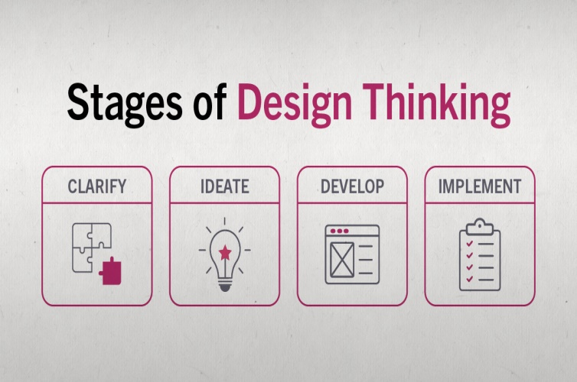  - Clarify: The clarification stage allows you to empathize with the user and identify problems. Observations and insights are informed by thorough research. Findings are then reframed as problem statements or questions.  - Ideate: Ideation is the process of coming up with innovative ideas. The divergence of ideas involved with creative problem-solving is a major focus.  - Develop: In the development stage, ideas evolve into experiments and tests. Ideas converge and are explored through prototyping and open critique.  - Implement: Implementation involves continuing to test and experiment to refine the solution and encourage its adoption. |  |  |  |  |  |  |  |  |  | Through questions and answers, conclude the lesson.  Exercise;  - State the four(4) stages of creative Problem solving.  - Write 3 problem solving tools.
Name of Teacher: School: District:

