BASIC 9
WEEKLY LESSON PLAN – WEEK 3
Strand: | Design |  |  | Sub-Strand: |  |  |  |  | Creativity, Innovation and the design process
Content Standard: | B9 1.3.1 Demonstrate understanding of creativity and innovation in terms of the design process and its application in developing design solutions to problems in society
Indicator (s) | B9 1.3.1.2 Demonstrate understanding of the design process in relation to creativity and innovations in design |  |  |  |  |  | Performance Indicator; Learners can apply design process skills.
Week Ending | 25-09-2026
Class | B.S.9 |  | Class Size: |  |  |  |  | Duration:
Subject | Creative Arts & Design
Reference | Creative Arts & Design Curriculum, Teachers Resource Pack, Learners Resource Pack, Textbook.
Teaching / Learning Resources | Poster and video showing steps in design process, Pictures displaying modified products. |  |  |  |  | Core Competencies: |  |  |  | - Communication and Collaboration.  - Critical Thinking and Problem Solving.  - Creativity and Innovation.
DAY/DATE | PHASE 1 : STARTER | PHASE 2: MAIN |  |  |  |  |  |  |  |  |  | PHASE 3: REFLECTION
WEDNESDAY | Discuss with the Learners on the meaning of “Design process”. | - Using a Poster and Pictures, explain the design process steps.  - Assist Learners to identify 5 importance of design process.  - Learners brainstorm to explain 5 challenges of design process.  Design process steps  The five main steps in the design process are ;  - Empathize,  - Define  - Ideate  - Deliver  - Test..  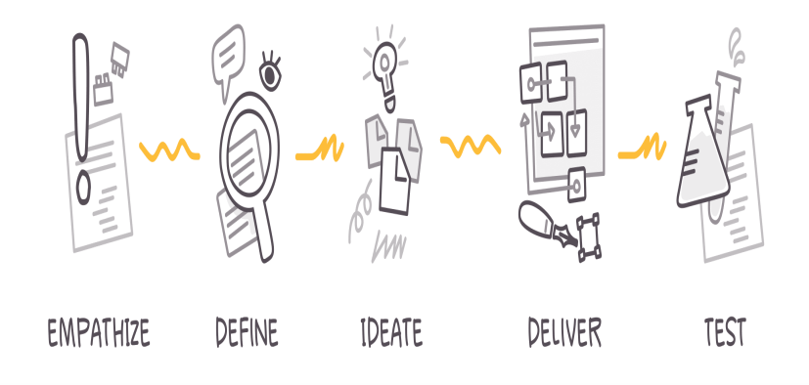  Importance of Design Process;  1. Set clearer expectations  While an individual designer’s creative process might be somewhat chaotic and messy, the design process as a whole is not. There’s a predictable sequence of activities that everyone in a larger organization can understand. As a result, timelines are more predictable and there’s less need to wonder “what’s happening with the design?”  2. Improve teamwork and alignment  You can have the most talented design team in the world, but it doesn’t matter if there isn’t clarity and a common workflow that gets everyone working in sync. Maintaining an organized design process leads to better teamwork and alignment by providing clarity on design scope and objectives, who is responsible for what, and which activities must happen in what order.  3. Create more efficiently  The design process is like a workflow template to follow, and we all know that templates help us all work faster. So with everyone on the same page, multidisciplinary team members know how and when they can contribute during the design process, which means you can make important design decisions more quickly along the way.  4. Deliver final designs that meet user and business needs  The design process forces you to consider your user and their needs from the very start, which reflects positively in your final design and user experience. And because the design process also gives space to proper delivery and testing, your team benefits from less friction during developer handoff and more certainty that the final designs meet all of the goals you intended for them.  5. Gain happy users  The ultimate goal for any design project is not just to solve a problem, but to also make users happy. The design process gives you that extra layer of assurance that you’re doing the right thing and creating something that your users will actually enjoy. |  |  |  |  |  |  |  |  |  | Reflect on the importance of design process.  Exercise;  - What is a design process?  - Write 5 importance of design process.  - Explain 3 challenges of design process.
THURSDAY | Review Learners knowledge on the previous lesson. | - Assist Learners to identify 5 ways of applying design process in creative problem solving.  - Discuss with the Learners on how a design process can be improved.  - Learners brainstorm to distinguish between design process and design thinking.  ways to improve the design process;  - to clearly define and communicate your design scope and goals across your team  - to reduce the manual work and friction for designers and developers during design delivery.  - Design Thinking: Design thinking refers to a human-centered approach to problem-solving and innovation. It emphasizes understanding the needs and desires of users or customers and finding creative solutions to meet those needs. Design thinking typically involves the following key stages:a. Empathize: Understanding the users, their perspectives, and their needs through observation and engagement. b. Define: Clearly defining the problem or challenge based on user insights. c. Ideate: Generating a wide range of ideas and potential solutions through brainstorming and creative thinking. d. Prototype: Building quick, low-fidelity prototypes to visualize and test potential solutions. e. Test: Gathering feedback on prototypes, iterating, and refining ideas based on user input. f. Implement: Bringing the chosen solution to life and incorporating user feedback into the final design.  Design thinking is often iterative and non-linear, allowing for multiple iterations and a flexible approach to problem-solving. It encourages collaboration, interdisciplinary thinking, and an emphasis on user needs throughout the design process.  - Design Process: The design process refers to a systematic, step-by-step approach to creating a solution or product. It encompasses the various stages involved in taking a design project from conception to completion. The design process typically includes the following stages:a. Research: Gathering information, conducting market analysis, and understanding the project requirements. b. Concept Development: Generating initial design concepts and exploring different possibilities. c. Refinement: Iteratively refining and developing the chosen concept, considering factors like functionality, aesthetics, and feasibility. d. Design Execution: Creating detailed drawings, specifications, and documentation necessary for production or implementation. e. Production: Manufacturing or constructing the design according to the specifications. f. Evaluation: Assessing the final product's performance, functionality, and user satisfaction.  The design process is often more linear and structured compared to design thinking, focusing on the systematic execution of tasks to bring a design from concept to reality. It may vary depending on the specific design discipline and industry. |  |  |  |  |  |  |  |  |  | Reflect on the application of design process.  Exercise;  - State 5 ways of applying design process.  - Explain 3 ways of improving design process.
Name of Teacher: School: District:

