BASIC 9
WEEKLY LESSON PLAN – WEEK 4
Strand: | Design |  |  | Sub-Strand: |  |  |  |  |  | Creativity, Innovation and the design process
Content Standard: | B9 1.3.1 Demonstrate understanding of creativity and innovation in terms of the design process and its application in developing design solutions to problems in society
Indicator (s) | B9 1.3.1.3 Demonstrate ability to apply the design process to create artefacts that solve specific problems in the local community |  |  |  |  |  | Performance Indicator Learners can apply the knowledge they have acquired in innovation and creativity.
Week Ending | 02-10-2026
Class | B.S.9 | Class Size: |  |  |  |  |  |  | Duration:
Subject | Creative Arts & Design
Reference | Creative Arts & Design Curriculum, Teachers Resource Pack, Learners Resource Pack, Textbook.
Teaching / Learning Resources | Poster and video showing steps in design process, Pictures displaying modified products |  |  |  |  | Core Competencies: |  | - Communication and Collaboration.  - Critical Thinking and Problem Solving.  - Creativity and Innovation.
DAY/DATE | PHASE 1 : STARTER |  | PHASE 2: MAIN |  |  |  |  | PHASE 3: REFLECTION
WEDNESDAY | Show Learners pictures and video of solving societal problems by applying the knowledge in creativity and innovation. |  | - Learners brainstorm to identify 5 environmental and social problems in their community.  - Assist Learners to explain how they can apply the knowledge they have acquired in creativity and innovation to solve the identified problems.  - Demonstrate to create artefacts that can solve societal problems whilst Learners observe.  Design thinking process;  The design thinking process is a problem-solving design methodology that helps you tackle complex problems by framing the issue in a human-centric way. The design thinking process works especially well for problems that are not clearly defined or have a more ambiguous goal  Problems that Design Thinking is known for solving:  - Finding human-centered solutions to business problems.  - Developing new products, features, and services.  - Improving processes, ways of working and operations.  - Designing business strategies and policies.  - Improving the efficiency and engagement of an organization.  - Influencing social change and community initiatives |  |  |  |  | Learners in small groups to create an artefacts applying design process.  Practical;  Make an artefact that can be used to collect and dump refuse in your community.
THURSDAY | Discuss the steps to follow to create artefacts applying the design process. |  | - Assist Learners to design and create model artefacts that express own concept for solving specific problems in the society.  - Inspect and appreciate Learners artefacts by giving appropriate comments.  - Assist Learners to display design expressions and prototypes of artefacts to disseminate own creativity and innovation for appreciation and feedback.  Design Process;  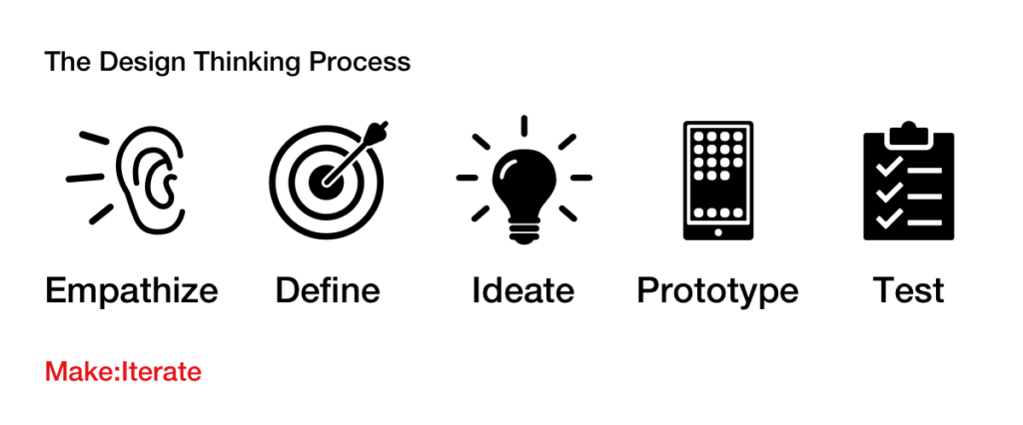  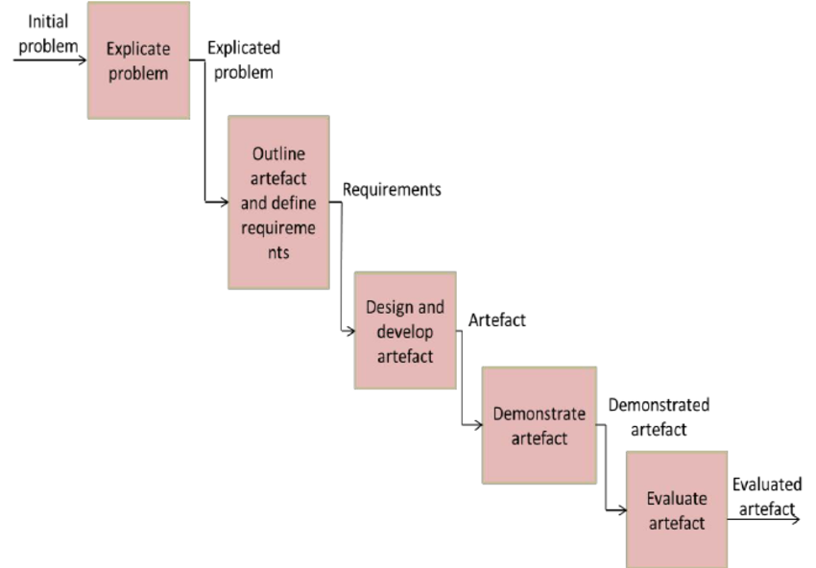 |  |  |  |  | Through questions and answers, conclude the lesson.
Name of Teacher: School: District:

