BASIC 9
WEEKLY LESSON PLAN – WEEK 4
Strand: | Number |  |  | Sub-Strand: |  |  |  |  | Number Operations
Content Standard: | B.9.1.2.1 Apply mental mathematics and properties to determine answers for addition and subtraction of basic facts.
Indicator (s) | B9.1.2.1.3 Use the associative property of addition and multiplication.  B9.1.2.1.4 Use the distributive property in solving problems. |  |  |  |  |  | Performance Indicator: Learners can solve word problems using associative and distributive property
Week Ending | 02-10-2026
Class | B.S.9 | Class Size: |  |  |  |  |  |  | Duration:
Subject | Mathematics
Reference | Mathematics Curriculum, Teachers Resource Pack, Learners Resource Pack, Textbook.
Teaching / Learning Resources | Poster, Video |  |  |  |  | Core Competencies: |  | - Demonstrate behaviour and skills of working towards group goals  - Ability to select alternative(s) that adequately meet selected  criteria
DAYS/DATE | PHASE 1 : STARTER |  | PHASE 2: MAIN |  |  |  |  |  | PHASE 3: REFLECTION
MONDAY | Explain the fun fact about associative property of Mathematics to the Learners.  Fun Fact!  The associative property gets its name from the word “associate”, and it refers to the grouping of numbers |  | - Assist Learners to identify the associative property of addition.  - Demonstrate solving examples of associative property of addition expressions whilst Learners observe.  - Engage Learners in solving more examples of associative property of addition expressions.  Associative Property of Addition  Associative property for addition implies that regardless of how numbers are grouped, the final sum of the numbers will remain the same. This can be expressed as:  (x + y) + z = x + (y + z)  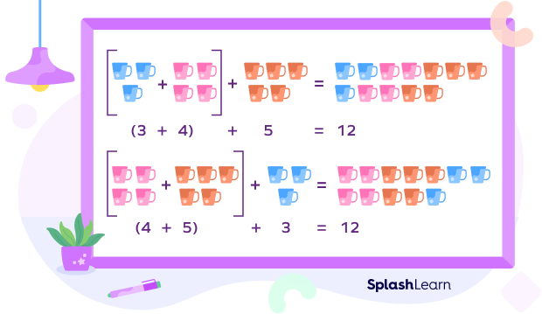 |  |  |  |  |  | Learners in small groups to discuss and solve more examples of questions on associative property of addition.  Exercise;  1. Is (5 + 10) + 4 the same as 5 + (10 + 4)?  2. Fill in the missing numbers:  21 + (45 + 36) = (21 + 45) + _ = _  3. Solve for x using the associative property formula: (2 + 3) + x = 2 + (3 + 6)
WEDNESDAY | Review Learners knowledge on the previous lesson. |  | - Assist Learners to explain the associative property of multiplication.  - Learners brainstorm to use the associative property of addition and multiplication in solving mathematics expressions.  - Learners in small groups to discuss and compare the rules of associative property of addition and multiplication.  - Engage Learners in finding the associative property of rational numbers.  Associative Property of-  Addition  2 + (5 + 6) = (2 + 5) + 6  2 + 11 = 7 + 6  13 = 13  Multiplication  2 × (5 × 6) = (2 × 5) × 6  2 × 30 = 10 × 6  60 = 60  Associative Property for Addition  The addition follows associative property i.e. regardless of how numbers are parenthesized the final sum of the numbers will be the same. Associative property of addition states that:  (x+y)+z = x+(y+z)  Let us say, we want to add 5+10+4. It can be seen that the answer is 19. Now, let us group the numbers; put 5 and 10 in the bracket. We get,  ⇒ (5+10)+4 = 15+4 = 19 (Remember BODMAS rule)  Now, let’s regroup the terms like 10 and 4 in brackets;  ⇒ 5+(10+4) = 5 + 14 = 19  Yes, it can be seen that the sum in both cases are the same. This is the associative property of addition.  Let us see some more examples.  (1) 3+(2+1) = (3+2)+1  3+3 = 5+1  6 = 6  L.H.S = R.H.S  (2) 4+(-6+2) = [4 + (-6)] + 2  4 + (-4) = [4-6] + 2  4-4 = -2+2  0 = 0  L.H.S = R.H.S  Associative Property for Multiplication  Rule for the associative property of multiplication is:  (xy) z = x (yz)  On solving 5×3×2, we get 30 as a product. Now as in addition, let’s group the terms:  ⇒ (5 × 3) × 2 = 15 × 2 = 30 (BODMAS rule)  After regrouping,  ⇒ 5 × (3 × 2) = 5 × 6 = 30  Products will be the same.  Thus, addition and multiplication are associative in nature but subtraction and division are not associative.  For example, divide 100 ÷ 10 ÷ 5  ⇒ (100 ÷ 10) ÷ 5 ≠ 100 ÷ (10 ÷ 5)  ⇒ (10) ÷ 5 ≠ 100 ÷ (2)  ⇒ 2 ≠ 50  Subtract, 3 − 2 − 1  ⇒ (3 − 2) − 1 ≠ 3 − (2 − 1)  ⇒ (1) – 1 ≠ 3 − (1)  ⇒ 0 ≠ 2  Hence, proved the associative property is not applicable for subtraction and division methods.  Associative property of Rational Numbers  Rational numbers follow the associative property for addition and multiplication.  Suppose a/b, c/d and e/f are rational, then the associativity of addition can be written as:  (a/b) + [(c/d) + (e/f)] = [(a/b) + (c/d)] + (e/f)  Similarly, the associativity of multiplication can be written as:  (a/b) × [(c/d) × (e/f)] = [(a/b) × (c/d)] × (e/f)  Example: Show that (½) + [(¾) + (⅚)] = [(½) + (¾)] + (⅚) and (½) × [(¾) × (⅚)] = [(½) × (¾)] × (⅚).  Solution: (1/2) + [(3/4) + (5/6)] = (1/2) + [(9 + 10)/12]  = (1/2) + (19/12)  = (6 + 19)/12  = 25/12  [(1/2) + (3/4)] + (5/6) = [(2 + 3)/4] + (5/6)  = (5/4) + (5/6)  = (15 + 10)/12  = 25/12  Therefore, (½) + [(¾) + (⅚)] = [(½) + (¾)] + (⅚)  Now, (1/2) × [(3/4) × (5/6)] = (1/2) × (15/24) = 15/48 = 5/16  [(1/2) × (3/4)] × (5/6) = (3/8) × (5/6) = 15/48 = 5/16  Therefore, (½) × [(¾) × (⅚)] = [(½) × (¾)] × (⅚) |  |  |  |  |  | Give Learners more examples of questions on finding the associative property of addition and multiplication.  Exercise;  To which operations Associative property is applicable?  What is the associative property?  Is the associative property applicable to division and subtraction?  Is multiplication always associative?  What is the general formula for an associative property?
FRIDAY | Assist Learners to identify the rule of distributive property.  Briefly explain the rule of distributive property. |  | - Demonstrate using both the order of operations and the distributive property to solve expressions.  - Learners brainstorm to identify the difference between using the order of operations and using the distributive property.  - Assist Learners to solve problems using the distributive property rule.  How to Use Distributive Property to Solve an Equation  Using the Basic Distributive Property  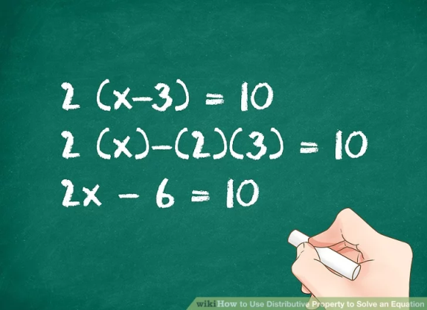  Multiply the term outside of the parentheses by each term in the parentheses. To do this, you are essentially distributing the outer term into the inner terms. Multiply the term outside the parentheses by the first term in the parentheses. Then multiply it by the second term. If there are more than two terms, keep distributing the term until there are no terms left. Keep whatever operation (plus or minus) is in the parentheses.[1]  Combine like terms. Before you can solve the equation, you will have to combine like terms. Combine all numerical terms with each other. Separately, combine any variable terms. To simplify the equation, arrange the terms so the variables are on one side of the equals sign and the constants (numbers only) are on the other.[2] |  |  |  |  |  | Through questions and answers, conclude the lesson.  Exercise;  - A family had their bill at a restaurant reduced by $7.50 because of a special discount. They left a tip of $8.90, which was 20% of the reduced amount. How much was their bill before the discount ?  - The members of a club spend 8% of their budget on entertainment. Their total budget for this year is $2,000 more than last year, and this year they plan to spend $3,840 on entertainment. What was their total budget last year ?

Name of Teacher: School: District

