BASIC 9
WEEKLY LESSON PLAN – WEEK 5
Strand: | Design |  |  | Sub-Strand: |  |  |  |  | Creativity, Innovation and the design process
Content Standard: | B9 1.3.1 Demonstrate understanding of creativity and innovation in terms of the design process and its application in developing design solutions to problems in society
Indicator (s) | B9 1.3.1.1 Distinguish between creativity and innovation and their application for developing design solutions to problems in society |  |  |  |  |  | Performance Indicator; Learners can identify the importance of design process.
Week Ending | 09-10-2026
Class | B.S.9 |  | Class Size: |  |  |  |  | Duration:
Subject | Creative Arts & Design
Reference | Creative Arts & Design Curriculum, Teachers Resource Pack, Learners Resource Pack, Textbook.
Teaching / Learning Resources | Poster and video showing steps in design process, Pictures displaying modified products |  |  |  |  | Core Competencies: |  |  |  | - Communication and Collaboration.  - Critical Thinking and Problem Solving.  - Creativity and Innovation.
DAY/DATE | PHASE 1 : STARTER | PHASE 2: MAIN |  |  |  |  |  |  |  |  |  | PHASE 3: REFLECTION
WEDNESDAY | Learners brainstorm to identify 5 importance of integrating design process in the school curriculum for students of all ages. | - Discuss with the Learners on the processes and best practices for bringing design process initiatives to the classrooms.  - Assist Learners to identify and explain the principles of design process and how they applied in solving problems.  - Learners brainstorm to make artefacts that can be used to solve problems in the school and in the classroom.  DESIGN PROCESS; is a non-linear, creative process that, depending on whom you ask, may contain somewhere between three to seven phases. Although there is plenty of DT process suggested in different research articles (Waidelich et al., 2018), this chapter emphasizes the five-stage design thinking methodology provided by Hasso Plattner, Stanford’s Institute of Design (D.School Public Library) since it is globally known for how it teaches and applies design thinking.  - Empathize: Investigate your users’ needs to empathize,  - Define: express your users’ requirements and issues,  - Ideate: explore the assumptions and develop new ideas,  - Prototype: begin to develop solutions,  - Test: Experiment with your solutions,  CHARACTERISTICS OF DESIGN Process  - Ambiguity: Feeling at ease when things are confusing or you don’t understand the solution,  - Collaboration: Collaborating across fields,  - Constructive: Developing new ideas from old ones, which may also be the most effective ideas,  - Inquisitiveness: A curiosity in things you don’t grasp or seeing things through new eyes,  - Empathy is the capacity to see and comprehend things through the eyes of your consumers,  - Holistic: Considering the bigger picture for the consumer,  - Iterative: A circular process in which improvements to a solution or concept are produced regardless of the stage,  - Non-judgmental: Developing ideas without reference to the author or the notion,  - Open mindset: Accepting design thinking as a solution to any challenge, irrespective of the industry or scope. |  |  |  |  |  |  |  |  |  | Reflect on the importance of design process in making artefacts.  Exercise;  State 5 importance of design process in making artefacts.
THURSDAY | Review Learners knowledge on the previous lesson. | - Assist Learners to create paper prototypes.  - Design the classroom walls with the paper prototypes created by the Learners.  - Display design expressions and prototypes of artefacts to disseminate own creativity and innovation for appreciation and feedback    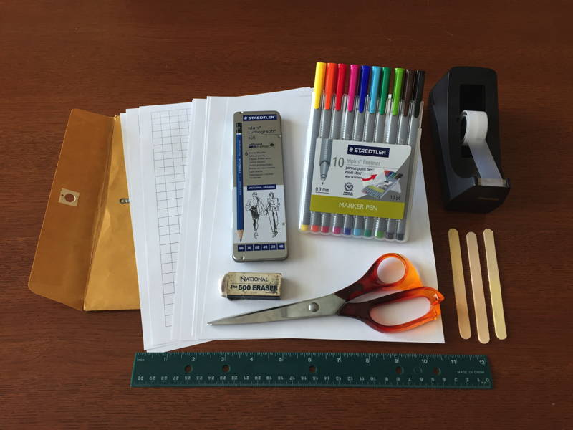  Creating Paper Prototype of Video Game  The paper prototype should include (as separate paper parts):  - game world  - user interface information displayed to player (such as: score, status, etc.)  - player's character  - non-player characters (opponents, allies, etc.)  - key game objects (resources, obstacles, etc.) |  |  |  |  |  |  |  |  |  | Learners brainstorm to explain why feedback is important in design.  Exercise;  Outline the steps for making a paper prototype.
Name of Teacher: School: District:

